**TRIBHUVAN UNIVERSITY**

**INSTITUTE OF ENGINEERING**

**Lab Sheet #8**

**PURWANCHAL CAMPUS**

DHARAN-8

**Submitted by:** **Submitted to:**

Name: **Arbind Kumar Mehta** Department of

Roll No: **PUR075BCT017** Electronics & Computer

Faculty: BCT Engineering

Group: I/I ‘A’

Date: ….......................... Checked by: ……………………….

**Title:**

Write a program to find separately the sum of the positive and negative integer elements of an array of size 10. Pass the positive and negative elements to separate functions eg: sumpositive(int*), sumnegative(int*) to carry out its sum. Also pass this array to a function called sortarray(int[]) and display the array elements into ascending order using pointer.

**Code:**

#include <stdio.h>

#include <stdlib.h>

int sum1(int *a)

{

int i,su1;

for(i=0;i<10;i++)

{

if(*(a+i)>0)

su1=su1+*(a+i);

}

return(su1);

}

int dif(int *a)

{

int i;

int dif=0;

for(i=0;i<10;i++)

{

if(*(a+i)<0)

dif=dif-*(a+i);

}

return(dif);

}

void sorarr(int *a)

{

int i,j,temp;

for(i=0;i<9;i++)

{

for(j=i+1;j<10;j++)

{

if(*(a+i)>*(a+j))

{

temp=*(a+i);

*(a+i)=*(a+j);

*(a+j)=temp;

}

}

}

printf("The sorted array is: ");

for(i=0;i<10;i++)

printf("%d ",*(a+i));

}

int main()

{

int a[10],i,j;

printf("Enter the element(integer) of the array:\n");

for(i=0;i<10;i++)

{

scanf("%d",&a[i]);

}

printf("The sum of positive element is:%d\n",sum1(a));

printf("The sum of negative element is:-%d\n",dif(a));

sorarr(a);

return 0;

}

**Output (Compilation, Debugging and Testing):**

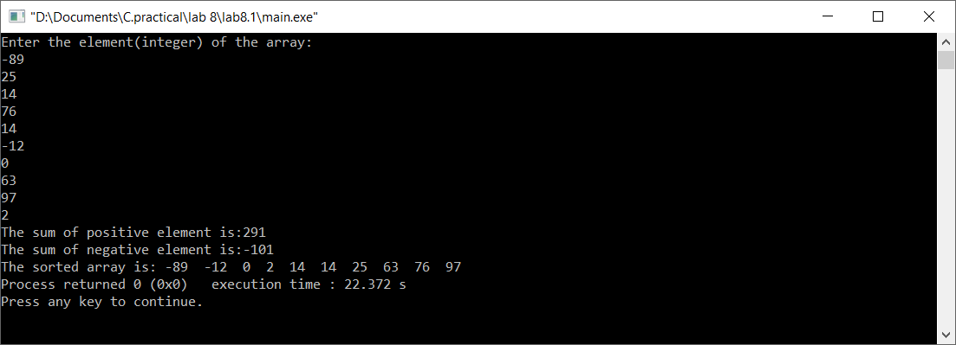

**Title:**

Write a program to find biggest among three numbers using pointer.

**Code:**

#include <stdio.h>

#include <stdlib.h>

int main()

{

int *n[3],i;

n[0]=(int*)malloc(3*sizeof(int));

printf("Enter three number(positive) to be compared:\n");

for(i=0;i<3;i++)

scanf("%d",(n+i));

if((*n>*(n+1))&&(*n>*(n+2)))

printf("%d is greatest.",*n);

if((*(n+1)>*(n+2))&&(*(n+1)>*n))

printf("%d is greatest.",*(n+1));

if((*(n+2)>*(n+1))&&(*(n+2)>*n))

printf("%d is greatest.",*(n+2));

return 0;

}

**Output (Compilation, Debugging and Testing)**

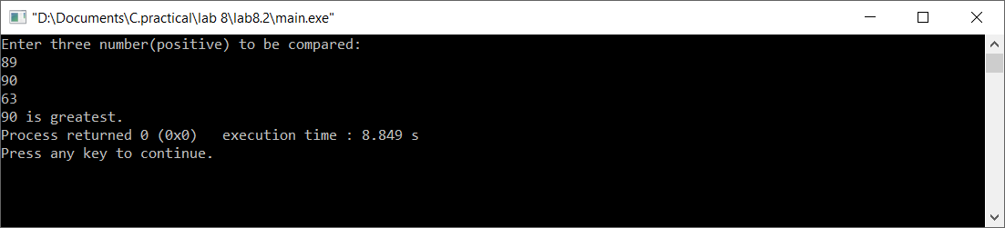

**Title:**

Write a program to find the sum of all the elements of an array using pointers.

**Code:**

#include <stdio.h>

#include <stdlib.h>

#include <string.h>

int main()

{

int *ptr,sum=0,n,i;

printf("Enter the number of element:\n");

scanf("%d",&n);

ptr=(int*)malloc(n*sizeof(int));

printf("Enter the element:\n");

for(i=0;i<n;i++)

{

scanf("%d",(ptr+i));

sum+=*(ptr+i);

}

printf("The sum of all element is:%d",sum);

return 0;

}

**Output (Compilation, Debugging and Testing):**

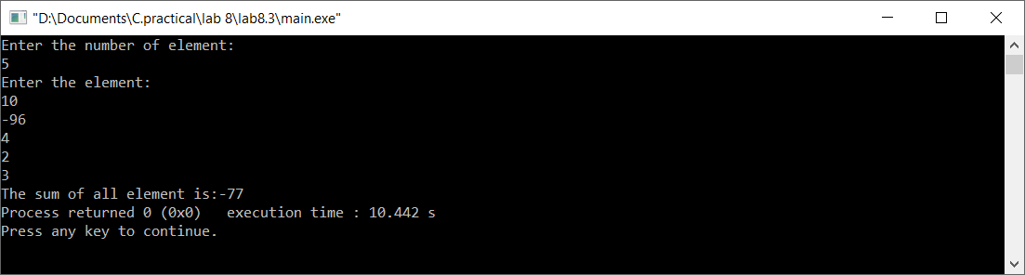

**Title:**

Write a program to swap value of two variables using pointer.

**Code:**

#include <stdio.h>

#include <stdlib.h>

int main()

{

char c1,c2,*p1,*p2,temp;

printf("Enter two character variables:\n");

scanf("%c %c",&c1,&c2);

p1=&c1;

p2=&c2;

temp=*p1;

*p1=*p2;

*p2=temp;

printf("The swapped result is:\n%c\n%c",*p1,*p2);

return 0;

}

**Output (Compilation, Debugging and Testing):** 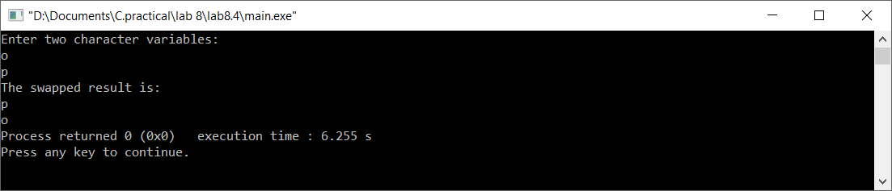

**Title:**

Write a program to read a sentence and count the number of characters &words in that sentence.

**Code:**

#include <stdio.h>

#include <stdlib.h>

int main()

{

char ch[100];

int i=0,car=0,wr=0;

printf("Enter a sentence:\n");

gets(ch);

while(ch[i]!='\0')

{

if(ch[i]==' ')

wr++;

car++;

i++;

}

printf("The number character and words in above sentence is %d and %d respectively.",car,wr+1);

return 0;

}

**Output (Compilation, Debugging and Testing):**

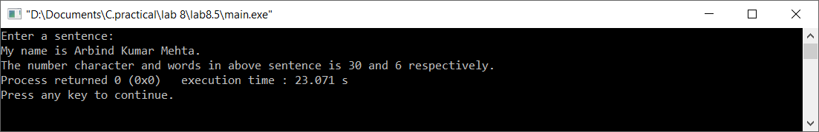

**Title:**

Write a program to read a sentence & delete all the white spaces. Replace all “.” by “:”.

**Code:**

#include <stdio.h>

#include <stdlib.h>

#include <string.h>

int main()

{

char ch[100],ne[100];

int i,j=0,n;

printf("Enter a sentence:\n");

gets(ch);

for(i=0;i<strlen(ch);i++)

{

if(ch[i]!=' ')

{

ch[j++]=ch[i];

}

}

ch[j]='\0';

for(i=0;i<strlen(ch);i++)

{

if(ch[i]=='.')

{

ch[i]=':';

}

}

printf("%s",ch);

return 0;

}

**Output (Compilation, Debugging and Testing):**

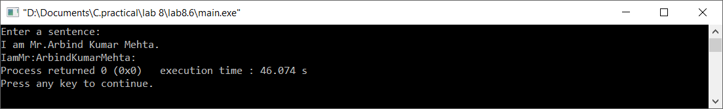

**Title:**

Write a program to copy one string to another string with and without using string handling function.

**Code:**

#include <stdio.h>

#include <stdlib.h>

#include <string.h>

int main()

{

int i=0,j,size=0;

char s1[]={"ARBIND KUMAR MEHTA"},s2[10];

while(s1[i]!='\0')

{

size++;

i++;

}

printf("The string s1 is: %s\nThe size of s1 is %d\n",s1,size);

for(i=0;i<size;i++)

{

s2[i]=s1[i];

}

s2[size]='\0';

printf("The string s2 is %s\n",s2);

return 0;

}

**Output (Compilation, Debugging and Testing):**

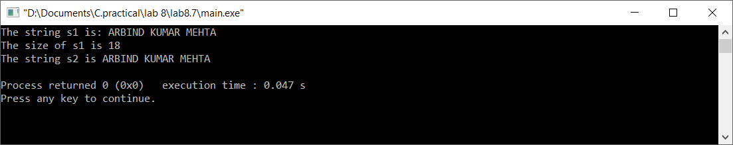

**Title:**

Write a program to concatenate two strings.

**Code:**

#include <stdio.h>

#include <stdlib.h>

#include <string.h>

int main()

{

char s1[20],s2[20],s[40];

int i=0,j=0;

printf("Enter the first string:\n");

gets(s1);

printf("Enter the second string:\n");

gets(s2);

//concaneting string

while(s1[i]!='\0')

{

s[i]=s1[i];

i++;

}

while(s2[j]!='\0')

{

s[i]=s2[j];

i++;

j++;

}

s[i]='\0';

printf("The concatenated string is:\n");

puts(s);

getch();

return 0;

}

**Output (Compilation, Debugging and Testing):**

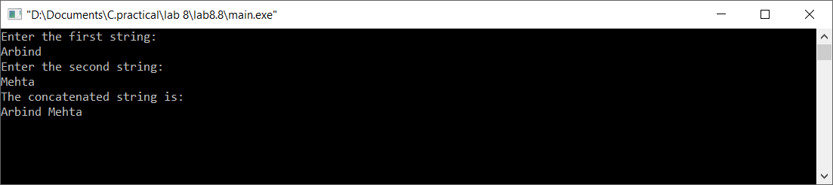

**Title:**

Write a program to compare two strings.

**Code:**

#include <stdio.h>

#include <stdlib.h>

int main()

{

char s1[20],s2[20];

int i=0,flag=0;

printf("Enter first string:\n");

gets(s1);

printf("Enter second string:\n");

gets(s2);

while(s1[i]!='\0'||s2[i]!='\0')

{

if(s1[i]!=s2[i])

flag=1;

i++;

}

if(flag==1)

printf("Two string are different.");

else

printf("Two string are same.");

getch();

return 0;

}

**Output (Compilation, Debugging and Testing):**

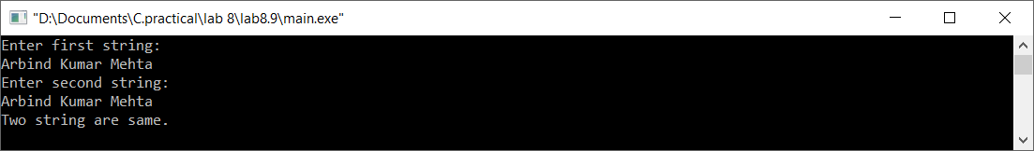

**Title:**

Write a program to sort 5 string words stored in an array of pointers.

**Code:**

#include <stdio.h>

#include <stdlib.h>

#include<string.h>

int main()

{

char (*s)[10];

char temp[10];

int i,n,j,k;

s=(char*)malloc(10*sizeof(char));

printf("Enter words to be sorted:\n");

for(i=0;i<5;i++)

{

scanf("%s",*(s+i));

}

printf("The words are:\n");

for(i=0;i<5;i++)

{

printf("%s\n",*(s+i));

}

for(i=0;i<4;i++)

{

for(j=i+1;j<5;j++)

{

if(strcmp(*(s+i),*(s+j))>0)

{

strcpy(temp,*(s+i));

strcpy(*(s+i),*(s+j));

strcpy(*(s+j),temp);

}

}

}

printf("\nThe sorted words are:\n");

for(i=0;i<5;i++)

{

printf("%s\n",*(s+i));

}

getch();

return 0;

}

**Output (Compilation, Debugging and Testing):**

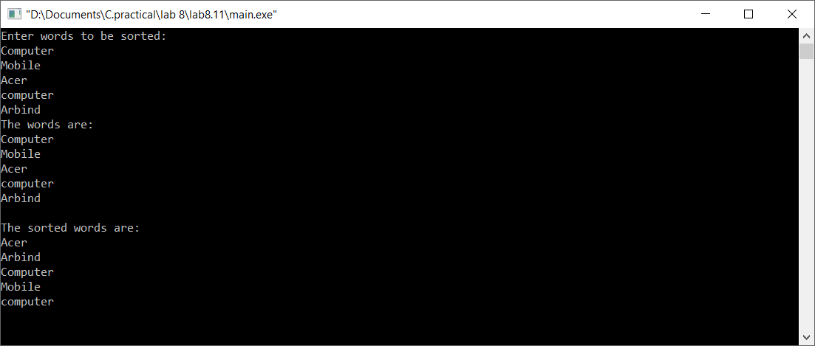

**Title:**

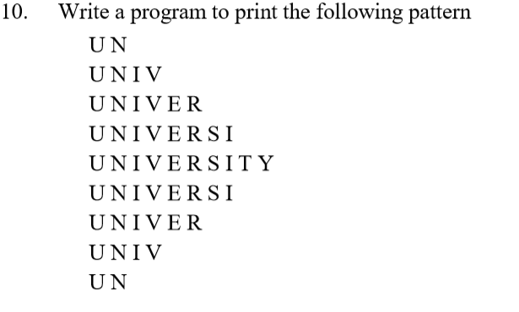

**Code:**

#include <stdio.h>

#include <stdlib.h>

int main()

{

int i,j;

char s[]="UNIVERSITY";

for(i=0;i<5;i++)

{

for(j=0;j<2+2*i;j++)

{

printf(" %c",s[j]);

}

printf("\n");

}

for(i=3;i>=0;i--)

{

for(j=0;j<2+2*i;j++)

{

printf(" %c",s[j]);

}

printf("\n");

}

return 0;

}

**Output (Compilation, Debugging and Testing):**



